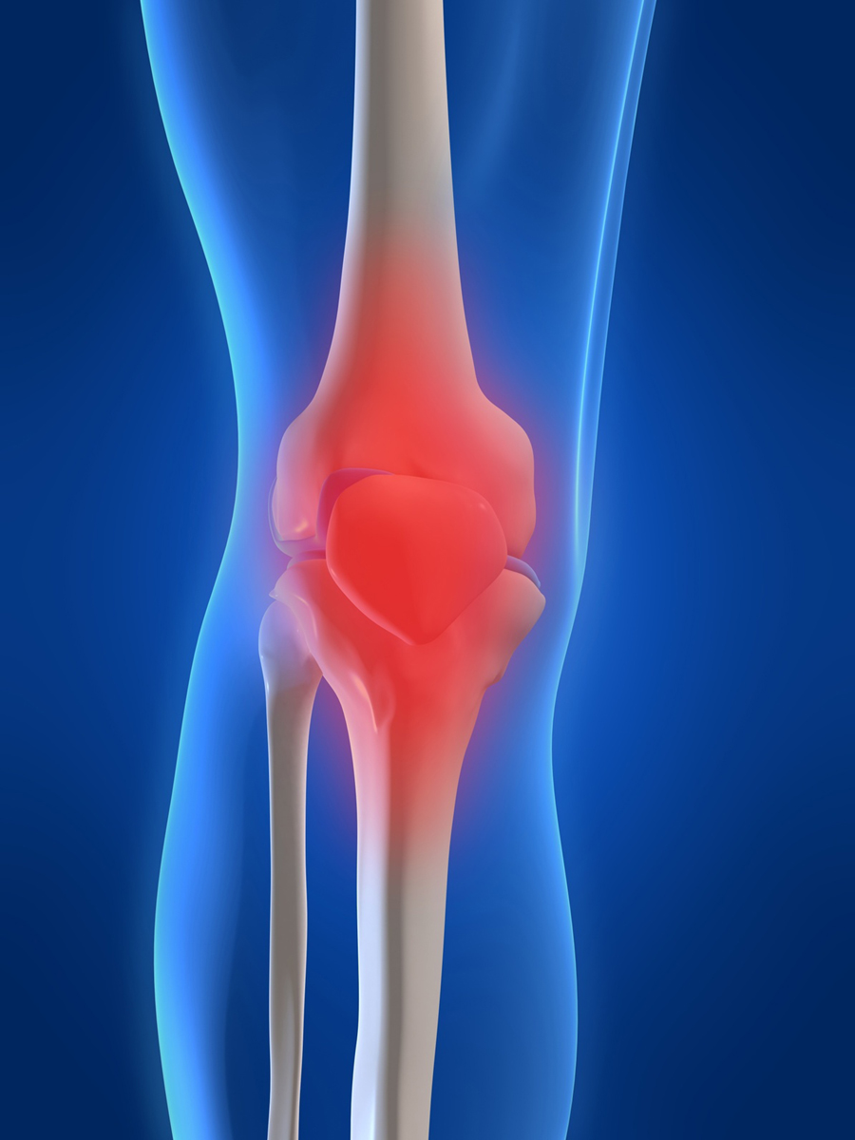
DownEast Surgery Center
DownEast Surgery Center
73 Ridgewood Drive,
Bangor, ME
207-990-0928

A Patient’s Guide
To Pre-Operative
Skin
Preparation

Pre Admission Testing.
Any Questions?
207-433-7039

73 Ridgewood Drive
Bangor, ME
04401
These instructions describe how your surgeon would like you to prepare for surgery.
The Pre-Admission Nurse will provide you with a bottle of Hibiclens (4 oz.). This is a special skin cleanser that your physician would like you to use when showering before surgery. If you receive a call from the pre-admission nurse and do not come in to see her, you may purchase the cleanser from most any pharmacy under the brand name Hibiclens, or under the generic name Chlorhexidine Gluconate. You will only need 4 oz. of cleaner.
If you want to shave your legs or underarms, please do this before your first shower. Do not shave the area of your surgery on the day of your surgery.
Your physician would like you to take two showers, one on the evening before your surgery and one on the morning of your surgery.

DownEast Surgery Center
A PATIENT’S GUIDE TO PRE-OPERATIVE SKIN PREPARATION
We need to be sure that your skin is as germ free as possible before surgery. You can help insure this by carefully washing before surgery. Following these instructions will help you be sure your skin is as clean as possible.
The evening before your surgery, use one half of your 4-oz. bottle of Hibiclens or 2 ounces. On the morning of your surgery repeat the process using the other 2 ounces of Hibiclens.
- Shampoo your hair, using your regular shampoo. Be sure to rinse thoroughly.
- Wash your face using your regular facial cleaner.
- Using a clean wash cloth and 2 ounces of the Hibiclens, wash from your neck down. This is very important. Pay special attention to the area where you will have your surgery.
- If you are having shoulder surgery, be sure to wash your underarm well.
- Gently wash for 5 minutes and rinse your body thoroughly.
- Use a clean, fresh towel to dry. Dress in freshly washed clothes.
- Use fresh clean sheets. .to.sleep in. pillowcases.

.
CAUTION!!!!
Do not use Hibiclens on your Head, Face or Groin.
Do not get Hibiclens in your eyes. If you do get it in your eyes, flush immediately with water.
AFTER SHOWERING
Do not use any lotions, powders, creams, hair products or Vaseline in the area of your surgery.

ANY QUESTIONS CALL ONE OF
OUR PRE-ADMISSION TESTING NURSES
207-990-0881

